**ISCAS-85 C880 8-Bit ALU**

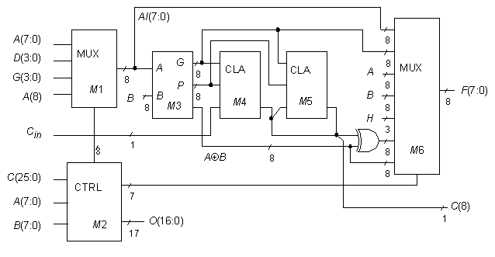

**Statistics:** 60 inputs; 26 outputs; 383 gates; [bus translations](http://web.eecs.umich.edu/%7Ejhayes/iscas.restore/c880bus.html)

**Function:** c880 is an 8-bit ALU with the high-level model shown in above. Given the presence of a CLA module in the [74181](http://web.eecs.umich.edu/%7Ejhayes/iscas.restore/74181.html) ALU, it is not surprising to find a similar module in c880. The core of this 8-bit ALU is an 8-bit 74283-style adder. The multiplexers M1 and M6 are both controlled by module M2 in a fashion reminiscent of horizontal microcode; i.e., an external source must ensure that no more than one function is activated at a time on C(25:0).

**Models:**

* [c880 ISCAS-85 netlist](http://web.eecs.umich.edu/%7Ejhayes/iscas.restore/c880.isc)
* [c880 Verilog hierarchical structural model](http://web.eecs.umich.edu/%7Ejhayes/iscas.restore/c880.v)
* [c880 Verilog hierarchical behavioral model](http://web.eecs.umich.edu/%7Ejhayes/iscas.restore/c880b.v)
* [c880 complete gate-level tests](http://web.eecs.umich.edu/%7Ejhayes/iscas.restore/c880.tests)

**ISCAS-85 C880 8-Bit ALU**

**Bus Translations**

|  |  |  |
| --- | --- | --- |
| I/O buses | Function | ISCAS-85 Netlist numbers |
| A[8:0] | Main A bus | 268,91, 96, 101, 106, 111, 116, 121, 126 |
| B[7:0] | Main B bus | 159, 165, 171, 177, 183, 189, 195, 201 |
| C[25:0] | Control bus | 207, 135, 156, 90, 89, 88, 87, 86, 85, 80, 75, 74, 73,  72, 68, 59, 55, 51, 42, 36, 29, 26, 17, 13, 8, 1 |
| D[3:0] | 4-bit bus | 143, 146, 149, 153 |
| F[7:0] | Output function | 878,879,880,874,863,864,865,850 |
| G[3:0] | 4-bit bus | 8, 51, 17, 152 |
| C in | Carry in | 261 |
| C8 | Carry out | 866 |